**Salesian Airlines**

**S.Y. 2022 – 2023**

In Partial Fulfillment of the Requirements for

**Information Communications Technology**

**SOFTWARE**

Presented by:

**CADIZ, JOSE ALFONSO F.**

**CHU, BERNARD MIGUEL V.**

**DECANO, GERALD SHANE JARI M.**

**GABUYA, MIGUEL CHRISTIAN A.**

**MURCIA, JOHANN ROMUALD E.**

**TORIO, SHAWN KAIZER D.**

**VILLANUEVA, KHIAN JORGE T.**

**ICT9 – F2F**

**Ms. Marivic R. Nabora**

**ICT – Software Teacher**

**Salesian Airlines**

**Objectives of the Study**

1. To provide easy online booking for flights for our customers by developing a simple, intuitive, and easily understandable user experience and interface.
2. To expand our booking services online for easy accessibility wherever the customer may be.
3. To give useful information about our services and our company.
4. To promote popular flight destinations to our customers.

**Scope and Limitations**

1. **Scope**
2. **Booking Options**

* There will be two types of booking: one-way and round-trip. Users can choose a destination, a date, and the number of passengers.

1. **Payment Options**

* The website will accept credit and debit card payments, PayPal, and local e-wallets like GCash or PayMaya.

1. **Information and History**

* The website will provide information about Salesian Airlines and the history behind the airline company.

1. **Promotions**

* The website also provides promotions for popular tourist destinations.

1. **FAQ**

* A guide for using and navigating the site will be included.

1. **Confirmation**

* The website will notify the user when their information has been uploaded to the database and will confirm if their flight has been successfully booked.

1. **Limitation**
2. **Destinations**

* Because Salesian Airlines is a domestic airline, it will only serve points in The Philippines. The website will offer flights to Manila, Clark, Cebu, and Davao and more than 30+ destinations within the Philippines.

1. **Booking Capacity**

* The booking form can only accommodate a maximum of 20 people per order.

1. **Fictional Contact Information and Social Media**

* Since Salesian Airlines is a fictional company, the contact information and social media on the website are nonexistent.

**Recommendation**

1. **Mobile Responsive**

* A large portion of people nowadays own mobile devices such as phones, tablets, etc. Such is the reason why we want to make our website not only available for PC or laptops but also for other mobile devices

1. **More Informational Articles on Popular destinations; Travel Blogs**

* We want to let our users know about the various beautiful destinations that they can travel to with Salesian Airlines, and so that they may know where they want to fly to next.

1. **More Security**

* It is imperative to us that our users’ sensitive information (such as their credit/debit card, address, phone number, etc.,) is well protected from leaks and hackers, which is why we need to prioritize upgrading our website’s security, like encrypting passwords using an encryptor.

1. **Extensive Documentation and Wiki**

* The website could use a full wiki to explain each function of the website.

1. **Specific Airline Plan Booking**

* Usually, booking a flight also includes flight class, seat preference, and any promos or plans that the user can specify or use. So, this is something that we recommend to add in our website.

1. **COVID-19 Protocols and Information**
2. **Specific Time and Flight Booking**

**System Design**

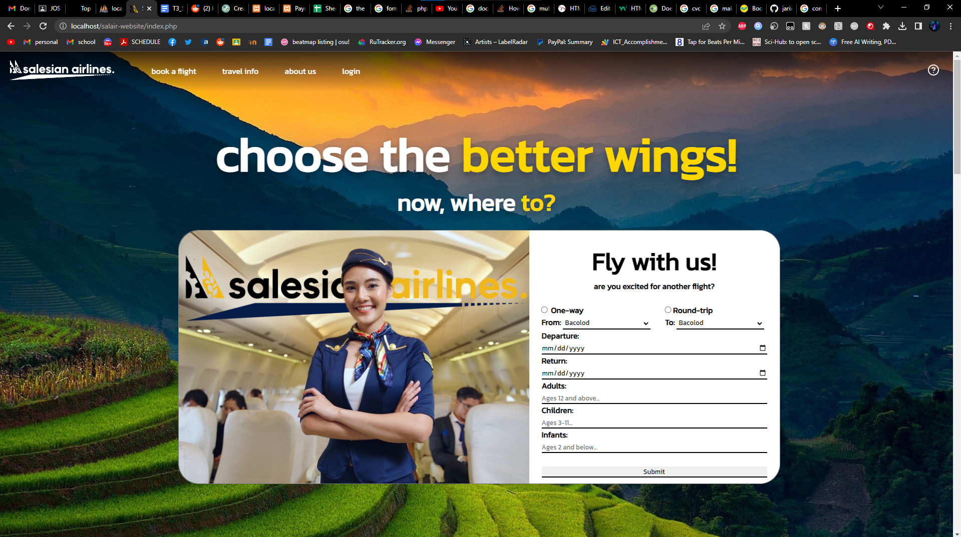

Figure 1. Home Screen w/ Quick Booking Form

**Description:**

Immediately visible to the user is the quick-booking form, for easy access to booking. At the top is the navigation bar, which is always present wherever you scroll. It includes six clickable elements, each leading to its own page.

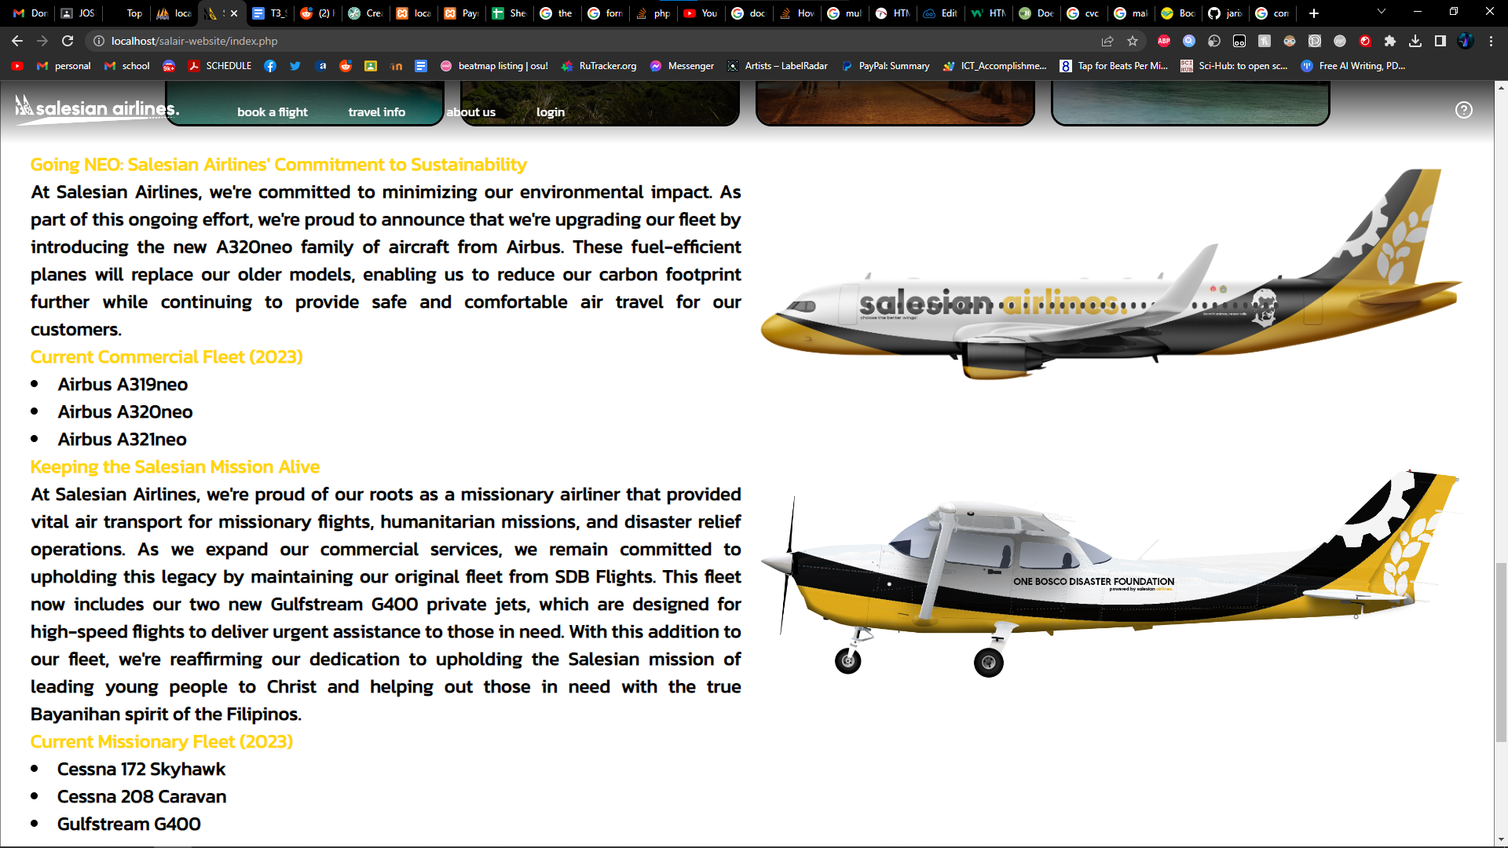

Figure 2. Bottom of the Home Page, Fleet Info

**Description:**

The bottom of the homepage includes information about our fleet, along with custom-made airplane livery designs with the Airbus A320neo and the Cessna 172 Skyhawk, and information about why we chose these planes.

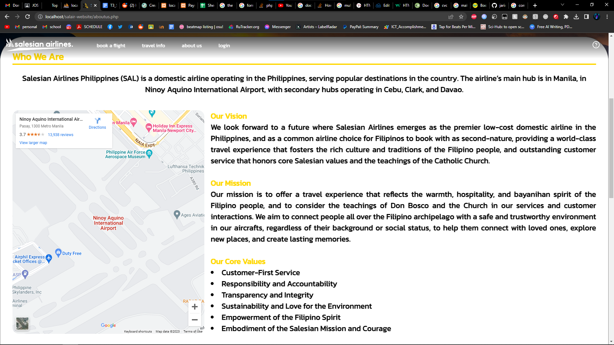

Figure 3. About Us Page

**Description:**  
The About Us page includes our vision-mission, and our core values, along with a short history of the airline company Salesian Airlines. It also includes an iframe for Google Maps that points directly at NAIA Airport.

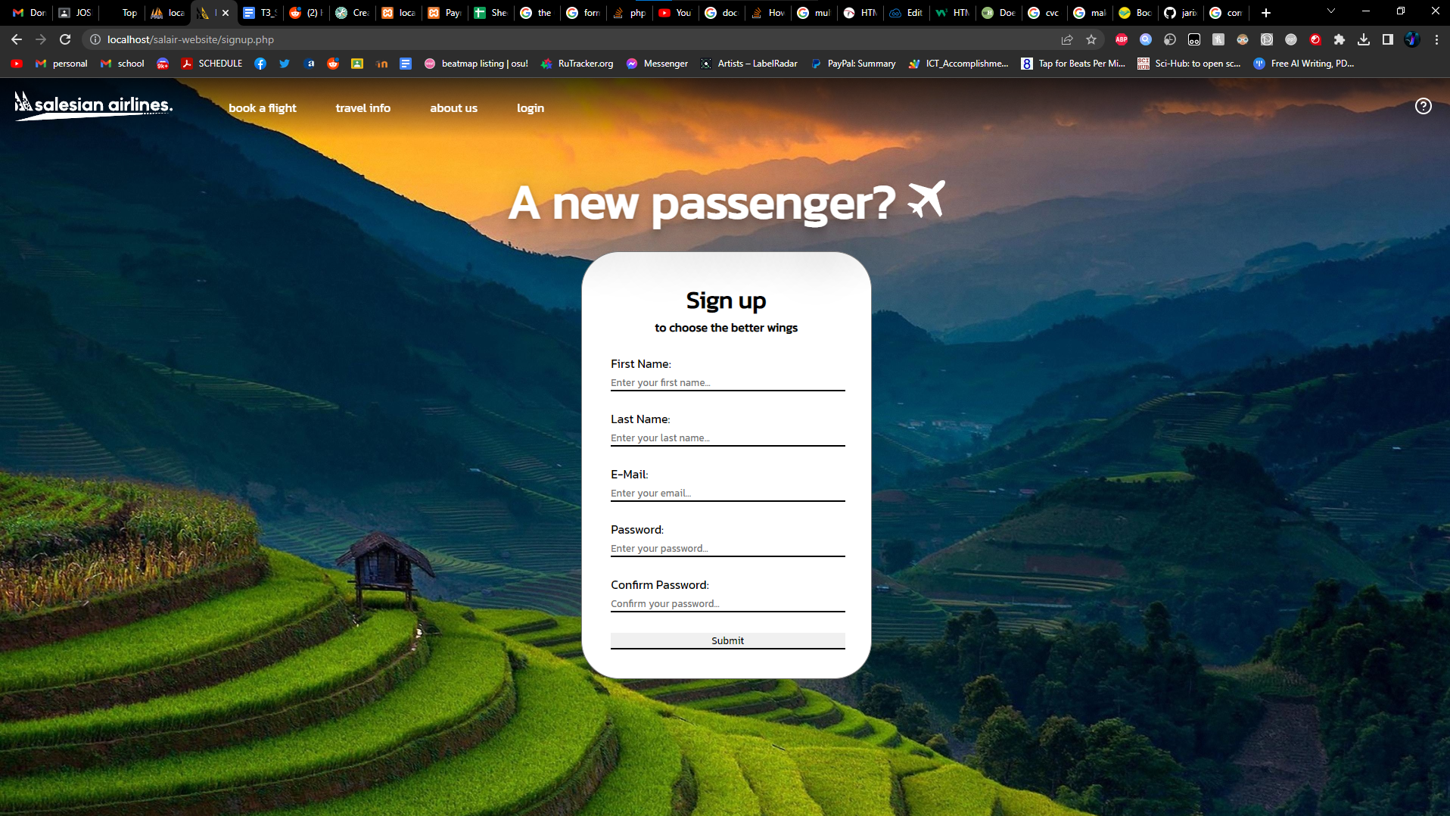

Figure 4. Sign Up Form

**Description:**

Here, users will be able to make an account for the Salesian Airlines website

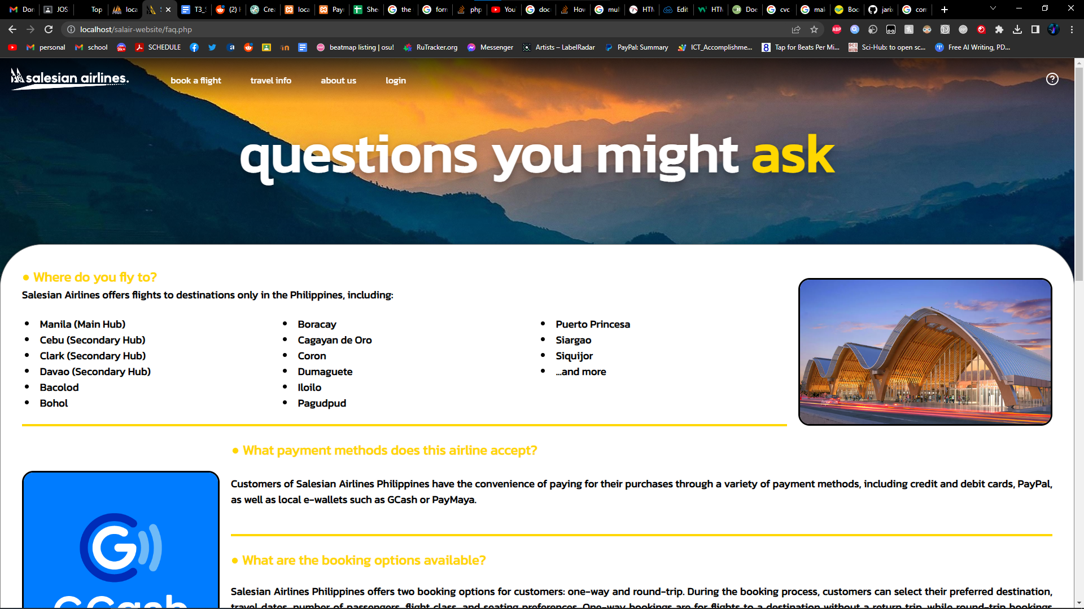

Figure 5. Frequently Asked Questions Page

**Description:**

Questions the user may have about the website and Salesian Airlines can be answered on this page. The Social Media and Contact Information of Salesian Airlines can also be found on this page.